AD23532 – PRINCIPLES OF DATA SCIENCE
EXPERIMENT 4: INFORMATION RETRIEVAL USING NLTK

QUESTION:
An e-commerce company receives thousands of customer reviews daily. Develop an information retrieval system using the Amazon Fine Food Reviews dataset to preprocess customer reviews, convert them into TF-IDF feature vectors, and retrieve the five most relevant reviews for a user query using cosine similarity.

AIM:
To implement an information retrieval system using NLTK by cleaning and preprocessing customer reviews, converting text into TF-IDF feature vectors, calculating cosine similarity, and retrieving the five most relevant reviews for a given search query.

ALGORITHM
- Import the required Python libraries, including Pandas, NLTK, Scikit-learn, and cosine similarity utilities.
- Load the Amazon Fine Food Reviews dataset into a Pandas DataFrame and retain the first 10,000 reviews.
- Remove missing and duplicate reviews and select the review text column.
- Preprocess the reviews by converting text to lowercase, removing punctuation, numbers, and special characters, tokenizing words, removing English stop words, and joining the cleaned tokens.
- Store the cleaned reviews in a new column named Cleaned_Text and display five sample reviews.
- Convert the cleaned reviews into TF-IDF feature vectors and display the matrix shape and vocabulary size.
- Create a retrieval function that preprocesses a user query, converts it into a TF-IDF vector, and calculates cosine similarity with all review vectors.
- Retrieve and display the top five most relevant reviews along with their similarity scores and original review text.
- Test the retrieval system using different queries and compare the relevance of the retrieved reviews.

PROGRAM & OUTPUT:
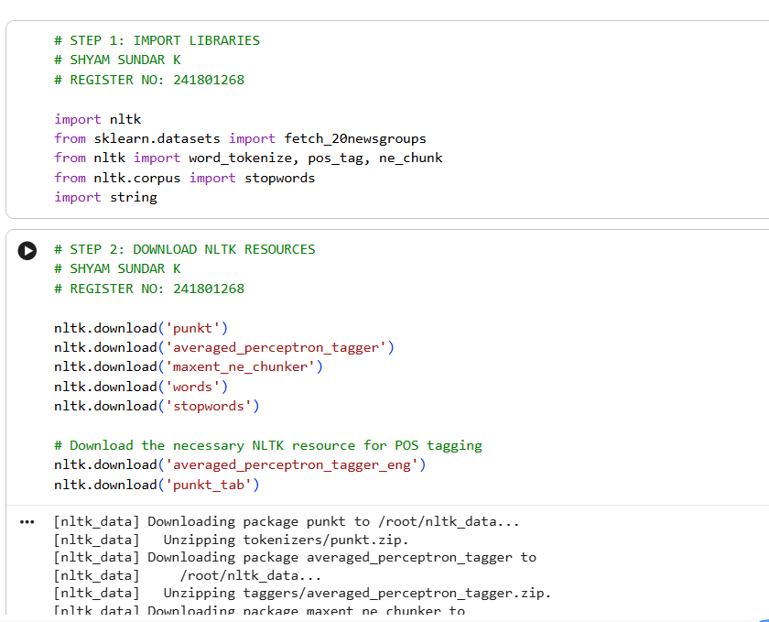
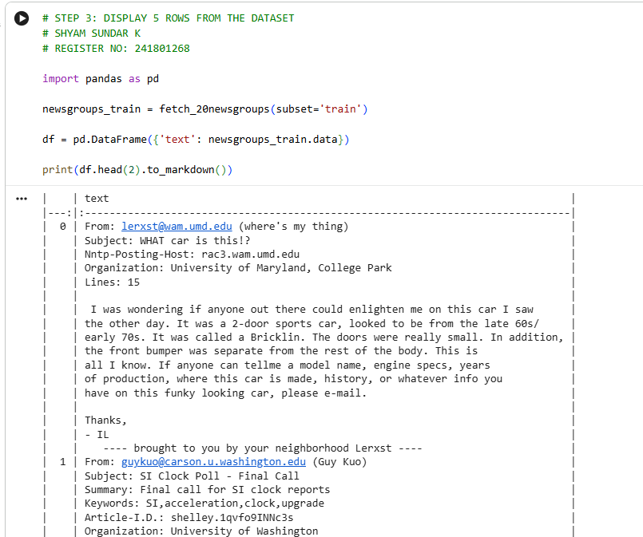
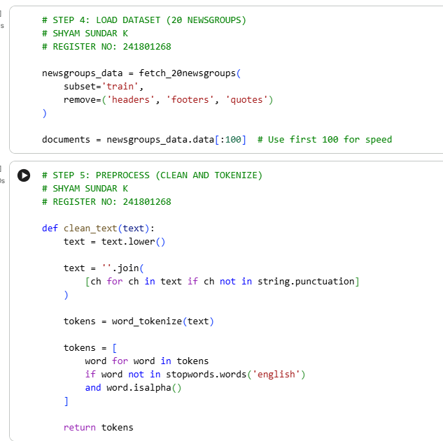
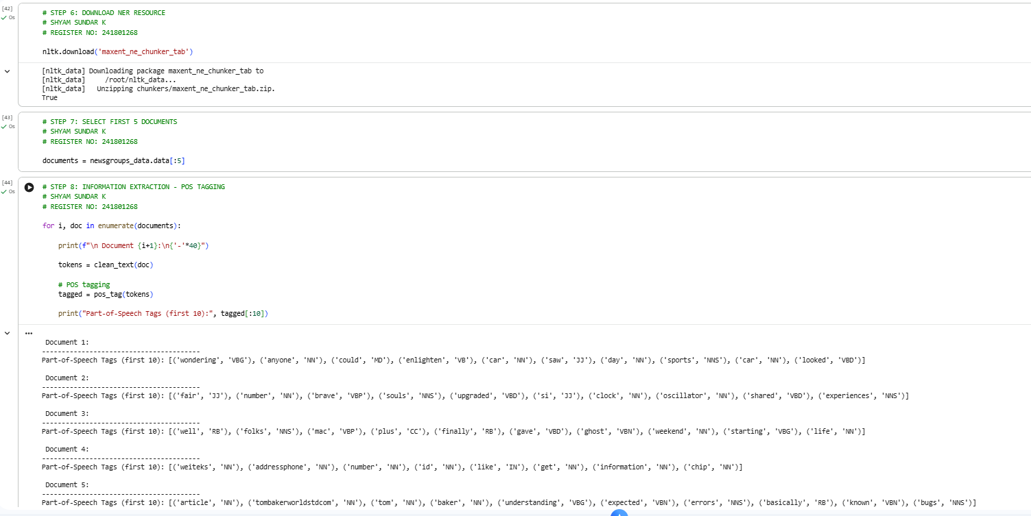
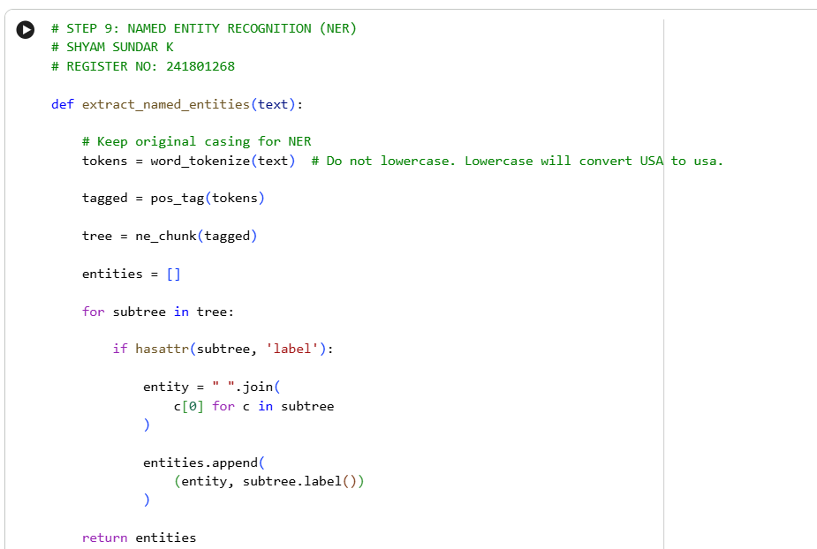
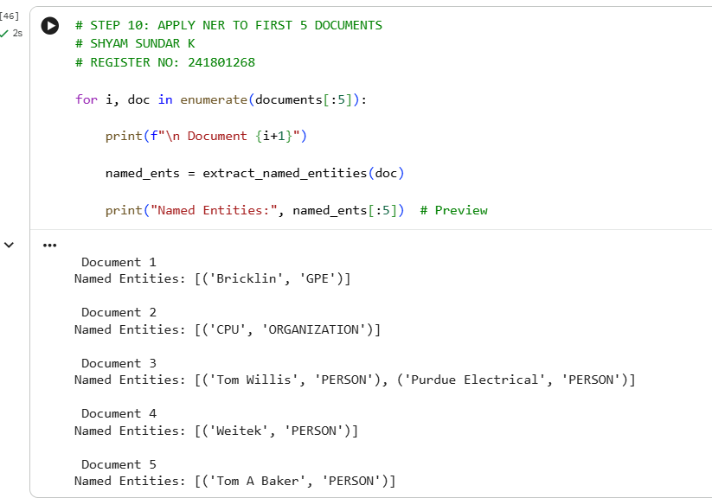
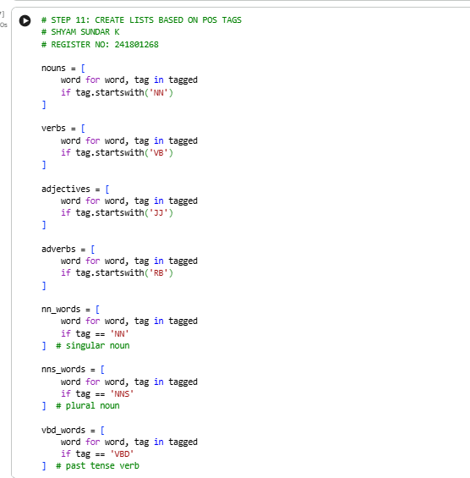
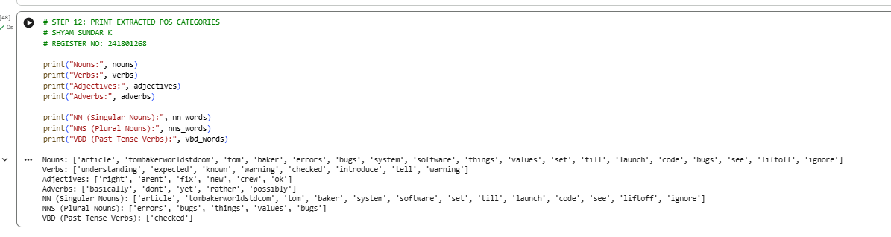

RESULT:
Thus, an information retrieval system was successfully implemented using NLTK and TF-IDF vectorization on the Amazon Fine Food Reviews dataset. Customer reviews were cleaned and preprocessed, converted into TF-IDF feature vectors, and compared using cosine similarity. The system retrieved the top five most relevant reviews for different search queries and displayed their similarity scores, helping users identify relevant customer feedback efficiently.

